### Name: CIS4655 - Module 3 Course Project

### Description: Adding Nav Bar to Course Project

### Student: Kenneth Janssen

Github: <https://github.com/KennethJanssen/CIS4655-Summer2019/tree/master/Module_3/project>

Sotd.us URL: <http://sotd.us/kennethjanssen/CIS4655-Summer2019/Module_3/project/index.html>

Comments:

* Since I added the Nav bar during Mod2, I have decided to make improvements
  + Pages besides Home have been duplicated to include the Fancy see through Image Navigation for Large Displays. On small displays the solid nav bar will be used and on very small screens the Nav will collapse to Hamburger.
* Overall clean up of mistakes from Mod2. I used a lot of fancy stuff so I spent time removing CSS that wasn’t used anymore such as the OWL-Carousel.
  + I did keep the animate.css as I liked how it added some transition effects to non-home pages.
* Switched over to a lot of CDN to keep the folder cleaner (bootstrap, awesomefont)
* Drop shadow on Text for Nav Bar – I found reading the nav bar menus overlaying the carousel image to be annoying so I added shadows to improve readability. This also could have been solved by picking better images with darker colors on the top but that seemed more limiting.
* Better understanding of Classes for spacing layouts. Example p = padding so p-3 is padding of 3 in all directions. This was helpful in learning that pt-3 would just add padding to the top.
* Got the Beautify plugin… so wonderful.

Issues:

* Carousel Image was limited to 750~ width which made it look wonky on a 1440p/1080p monitor because it only ever took up half the screen. I just put in a max-height limit for image which works for now. I really should have higher res homepage images for larger resolutions.
* Because I’m messing with Nav-bar after the other pages are already created, I found myself forgetting to update links for tweaks I’d do. Example – I’d copy the ‘About Us’ nav bar banner code to ratings page but then forget to update the img.jpg or other things.
* Because the Images are smaller on non Homepage because Homepage Image is much larger vertically, I had to adjust code to ‘hide’ paragraph message on small screens. I’m still not ‘happy’ with how it is but its functional for now. So H1 removes on small screens and <P> should remove on small and medium.  
  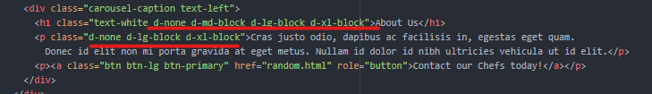

# About Us – Improved Nav to similar style as Homepage

Chefs are still a 3 Column grid

Mod2 version

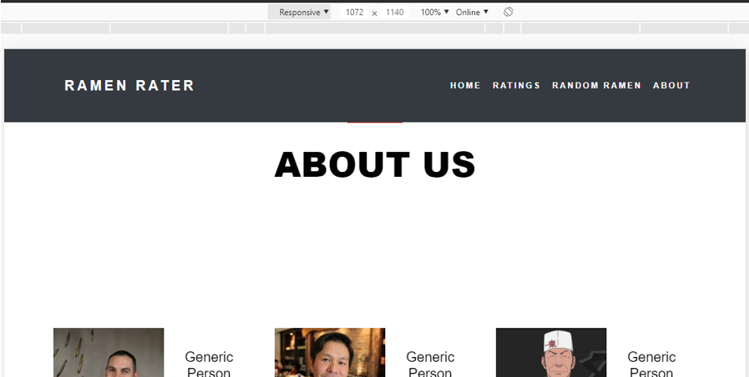

Mod 3 version – I used a single slide Carosual like homepage.



# Home Page – Large Screen (1920x1080)

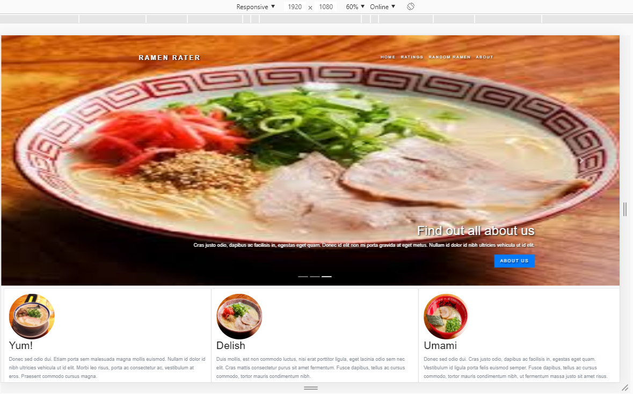

# Home Page – Medium (iPad) Landscape & Portrait

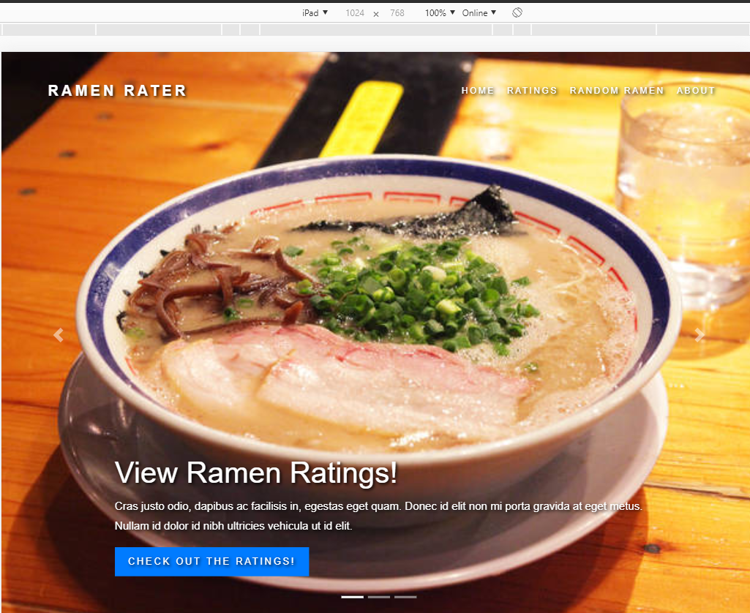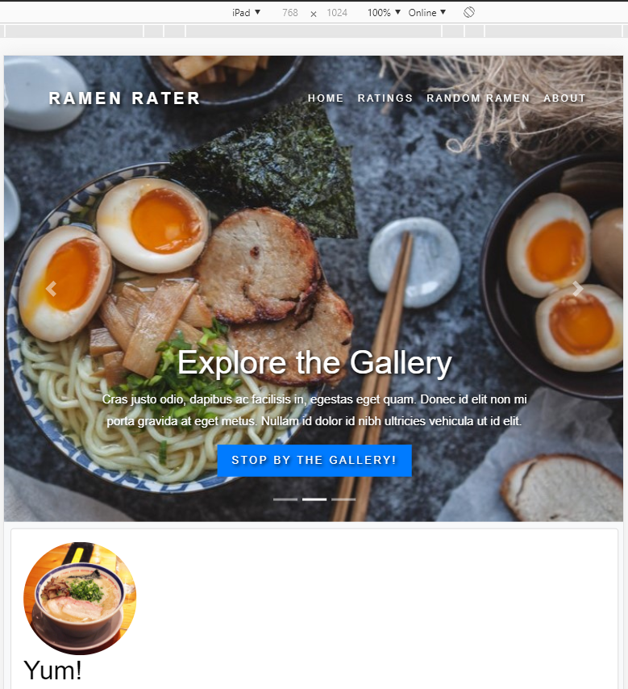

# Home Page – Small (iPhone 6) Collapsed Nav – Landscape and Portrait (Open closed Menu)

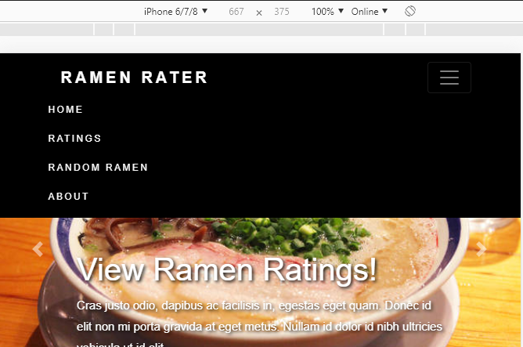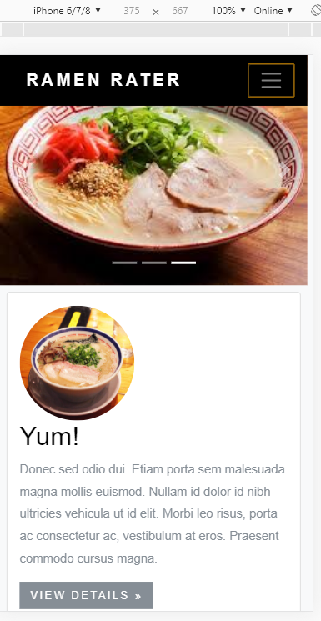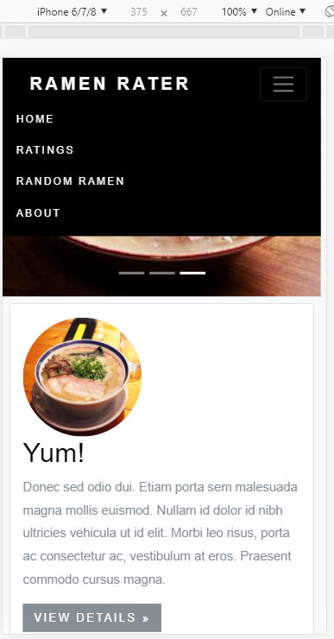

# Before & After Images of “gutter’ Issue – The sides were not going all the way to Edge of screen.

NOTE- See how the image doesn’t expand all the way over – This was before adding the Max-Height to clean that up.

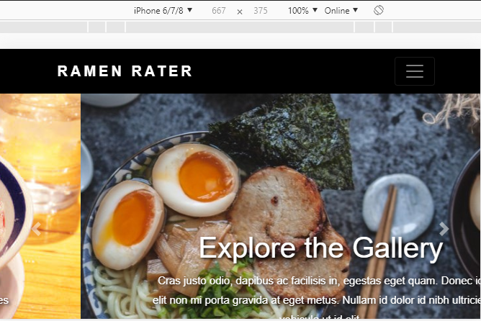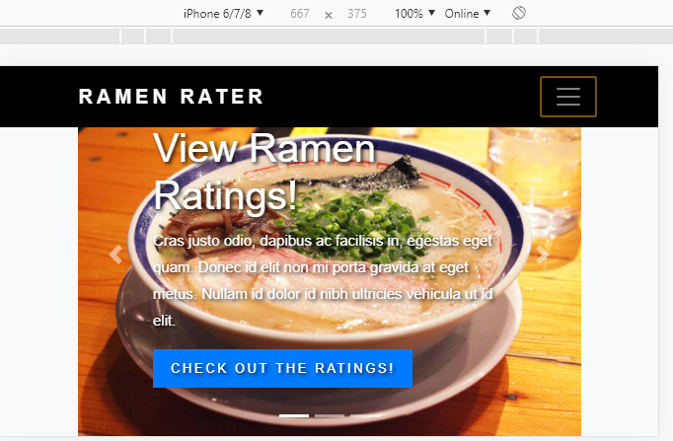

Before fixing

Note: Image just stops in the gutter

After fixing – Wide screen

Note: Image goes to edge